Web Application Assignment 1

Ruiyu Zhang || rz213

2019.02.05

**Question 1**

1. ER-Diagram

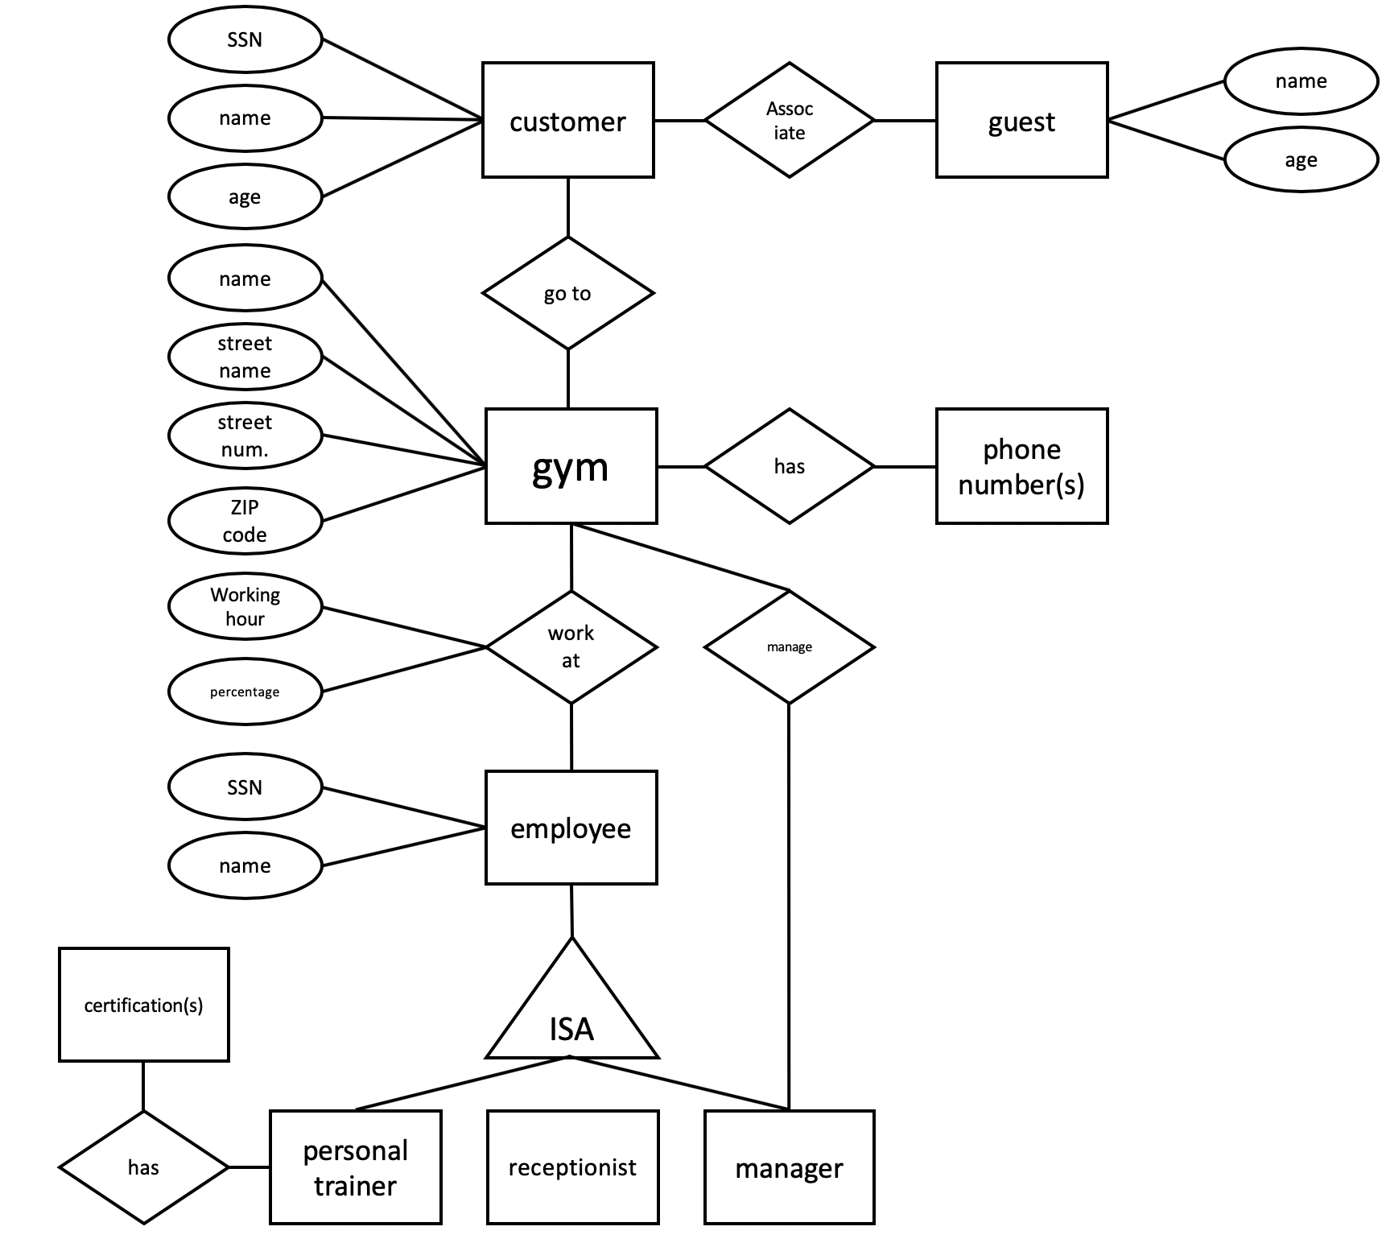

1. Table codes